The Pledge
By signing the Pledge, your council is agreeing that the council will treat councillors, clerks, employees, members of the public, and representatives of partner organisations and volunteers with civility and respect in their roles and that it:
- Has put in place a training programme for councillors and staff
- Has signed up to the Code of Conduct for councillors
- Has good governance arrangements in place including staff contracts and a dignity at work policy
- Will seek professional help at the early stages should civility and respect issues arise
- Will commit to calling out bullying and harassment if and when it happens
- Will continue to learn from best practices in the sector and aspire to be a role model/champion council through for example the local Local Council Award Scheme
- Supports the continued lobbying for change in legislation to support the Civility and Respect Pledge including sanctions for elected members where appropriate
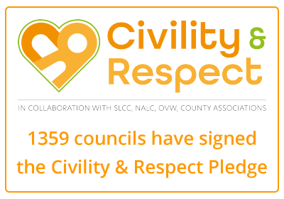

Please complete this form to sign up your council to the pledge. Once completed, you'll receive a certificate by email, and your council will be listed alongside others a national map, showing the councils that have signed up.

By signing the Pledge, your council is agreeing that the council will treat councillors, clerks, employees, members of the public, and representatives of partner organisations and volunteers with civility and respect in their roles and that it:
- Has put in place a training programme for councillors and staff
- Has signed up to the Code of Conduct for councillors
- Has good governance arrangements in place including staff contracts and a dignity at work policy
- Will seek professional help at the early stages should civility and respect issues arise
- Will commit to calling out bullying and harassment if and when it happens
- Will continue to learn from best practices in the sector and aspire to be a role model/champion council through for example the local Local Council Award Scheme
- Supports the continued lobbying for change in legislation to support the Civility and Respect Pledge including sanctions for elected members where appropriate
- Data Protection *
The National Association of Local Councils (NALC) takes data protection seriously. NALC will process any personal data you give us for the purpose of your council taking the Civility & Respect Pledge. NALC is the data controller, and your data will be processed under the lawful basis of legitimate interest. If you wish to have your data removed from the Civility & Respect pledge register, you can request that at any time. Your personal data will be kept for two years after which time we will remove your personal data from your council's entry on the Civility & Respect Pledge register. To view NALC's privacy notice, related policies or to exercise your data protection rights please see https://www.nalc.gov.uk/generalprivacynotice
I accept

MISSION STATEMENT
Civility and respect should be at the heart of public life, and good governance is fundamental to ensuring an effective and well-functioning democracy at all levels.
The intimidation, abuse, bullying and harassment of councillors, clerks and council staff, in person or online, is unacceptable, whether by councillors, clerks, council staff, or public members.
This can prevent councils from functioning effectively, councillors from representing local people, discourage people from getting involved, including standing for election, and undermine public confidence and trust in local democracy.
NALC, county associations and OVW, as the membership organisations representing the first tier of local government in England and Wales, and the SLCC, as the professional body for clerks, are committed to working together to promote civility and respect in public life, good governance, positive debate and supporting the well-being of councillors, professional officers and staff.
To that end, the Civility and Respect Working Group will be working to deliver tangible resources, actions and interventions in four main areas: providing councils with the tools to support good governance; lobbying to strengthen the standards regime and encouraging more people to get involved; training; and processes to intervene to provide support to struggling councils.

